A1123-Asia-China-Guanyin-Gold and Bronze-12th Century CE

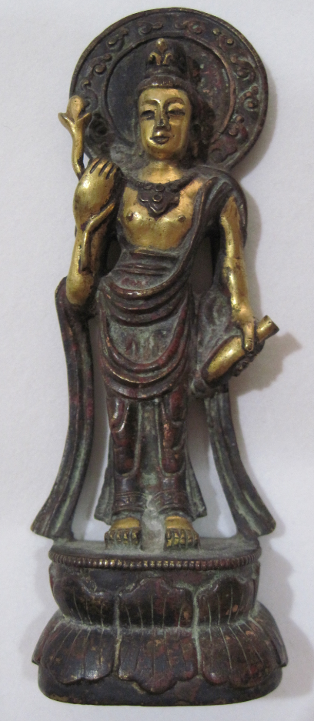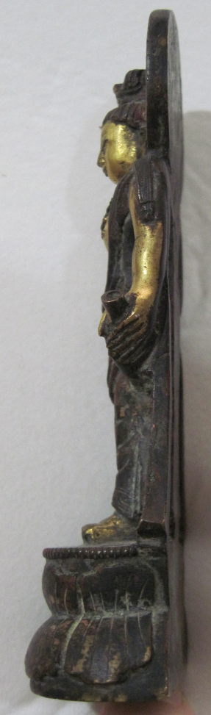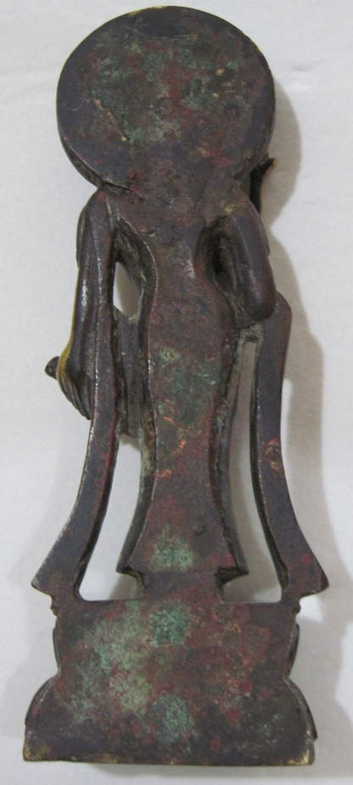

Fig. 1. China-Guanyin-Gold and Bronze-12th Century CE

**Case no.: 3**

**Accession Number: A337**

**Formal Label:** Gandhara-Avalokiteśvara-Gold and Bronze-Kushan Period-4th Century CE

**Display Description:**

Chinese pilgrims had been attracted to worship at Buddhist monuments along the Silk Road from the 8th to the 12th centuries AD/CE. Mahayana Buddhism represented the Buddha in human form and many new sculptures of the Buddha were carved and new stupas and painted and sculptured caves were built while others were enlarged. In addition, Avalokiteśvara  a bodhisattva who embodies the compassion of all Buddhaswas portrayed in Chinese Buddhism as Guanyin, or Guanshiyin, meaning "[The One Who] Perceives the Sounds of the World," an East Asian bodhisattva associated with compassion by Mahayana Buddhists (Doré and Kennelly 1914, 1: 2). Some Buddhists believe that when one of their adherents departs from this world, they are placed by Guanyin in the heart of a lotus, and then sent to the western Pure Land of Sukhāvatī (Johnson 1913). Guanyin is beseeched to assist all those who pray to her, as is said in the Lotus and Karandavyuha Sutras.

This particular sculpture is culturally important in that it shows Avalokiteśvara as Guanyin perhaps in Hellenistic style folded robes harkening back to Gandhara but noe with a Chinese aspect representing her cultural transformation.

**LC Classification**: [NB992.2.K36](http://josiah.brown.edu/search~S7?/c2-SIZE+NB992.2.K36+B87+1978/cnb++992.2+k36+b87+1978/-3%2C-1%2C0%2CE/frameset&FF=cnb++992.2+k36+b87+1978&1%2C1%2C)

**Date or Time Horizon:** China, 12th century

**Geographical Area:** perhaps Dunhuang.

|  |  |
| --- | --- |
|  |  |

**Map, GPS coordinates:** 40.14213 94.66197;40° 26' 46" N 79° 58' 56" W.

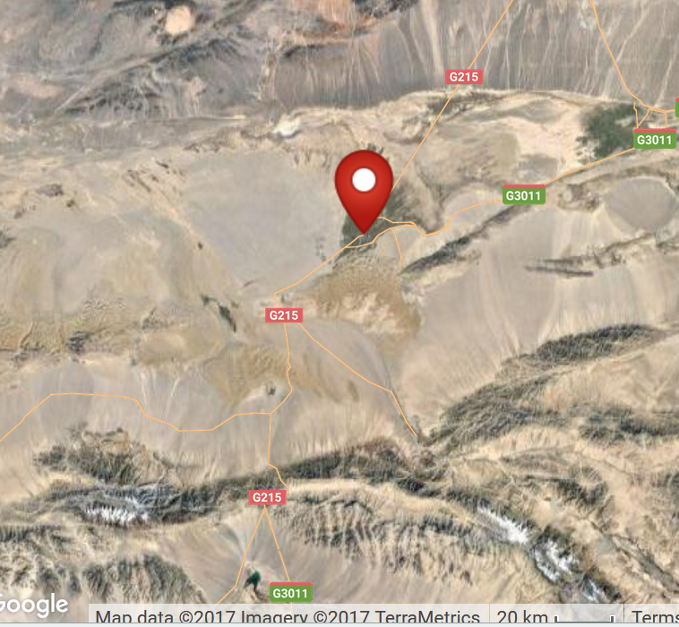

**Cultural Affiliation:** Gandhara

**Medium:** schist.

**Dimensions:** H 162.18 mm; 6.39 in.

**Weight: 411 gm; 14 3/8 oz.**

**Condition: original**

**Provenance:** unknown

**Discussion:**

From the West along the Silk Road came early Buddhist monks who had arrived in China by the first century AD/CE, and they developed a vibrant Buddhist community that devoted itself to excavating, carving and painting the caves at the site (Mogao Caves or "Caves of a Thousand Buddhas) which they used for meditation and pilgrimage. Other Christian, Jewish, and Manichaean pilgrims also worshipped at the caves where they left their precious manuscripts (i.e., the Jesus Sutras).

**References:**

Allchin, Bridget and Raymond Allchin. 1988. *The rise of civilization in India and Pakistan.* Cambridge: Cambridge University Press.

Allchin, F. Raymond. 1993. "The Urban Position of Taxila and Its Place in Northwest India-Pakistan," *Studies in the History of Art*, 31: 69–81.

Cunningham, Alexander. 1871. *The Ancient Geography of India: The Buddhist Period, Including the Campaigns of Alexander, and the Travels of Hwen-Thsang*. Cambridge: Cambridge University Press.

Doré S.J., Henry and M. Kennelly, S.J. 1914. Researches into Chinese Superstitions. Shanghai: Tusewei Press. 2 v.

Johnson, Reginald. 2008 [1913]. *Buddhist China*. Beijing: Soul Care Publishing.

Marshall, John. 1960. *A guide to Taxila* (4th ed.). Cambridge: Cambridge University Press.

Marshall, John. 1951. *Taxila: an illustrated account of archaeological excavations carried out at Taxila under the orders of the Government of India between the years 1913 and 1914*. 3 v. Delhi: Barnasidass

Oort, H A van. 1986. *The iconography of Chinese Buddhism in traditional China. Iconography of religions*, Section 12,, East- and Central Asia; fasc. 5, 1-2. Leiden: Brill.